Tail dependence: NZDUSD and USDCHF
Method 19 / daily log returns / alpha=0.05 / Alpari D1 full available history

Study setup
Logical pair: NZDUSD , USDCHF
Broker symbols: NZDUSD_i , USDCHF_i
Snapshot: 2026-11-03_majors_alpari_D1
Timeframe: D1
Matched return window: 1999-01-05 to 2026-11-02 (UTC bar dates)
Matched return count n: 7185
Dropped unfinished last bar dated 2026-11-03 UTC after a tick-volume check against the prior complete day.
Uniforms: ranks/(n+1); alpha=0.05
Complete matched rows (Excel): NZDUSD-USDCHF_Tail_D1.xlsx
Complete matched rows (HTML table): NZDUSD-USDCHF_Tail_D1_data.html

Method carried forward
Tail dependence counts how often both legs sit in an extreme uniform tail together. Matched daily log returns of close, ln(close_t / close_t-1), become u_i = rank(x_i)/(n+1) and v_i = rank(y_i)/(n+1). At alpha=0.05, lower L_hat = (# u<=alpha and v<=alpha) / (# conditioning leg <= alpha); upper uses >= 1-alpha. Both conditioning directions are reported with numerator and denominator counts. Quotes are not inverted. L_hat(0.05) is a finite-sample frequency, not the asymptotic lambda. Same-sample Pearson r is a side check. This is not causation and not a trading signal.

Results
tail | cond | L_hat | num | denom
lower | USDCHF | 0.030641 | 11 | 359
lower | NZDUSD | 0.030641 | 11 | 359
upper | USDCHF | 0.038997 | 14 | 359
upper | NZDUSD | 0.038997 | 14 | 359
Pearson r on returns: -0.393600

Conclusion
Over 7185 matched daily rows for NZDUSD and USDCHF at alpha=0.05, lower L_hat conditioning on USDCHF is 0.0306 (11/359); conditioning on NZDUSD is 0.0306. Upper L_hat conditioning on USDCHF is 0.0390; on NZDUSD is 0.0390. Pearson r = -0.3936. These are finite-sample frequencies, not asymptotic lambda and not a trading signal.

Charts
Daily closes

Daily log returns

Uniforms with alpha lines
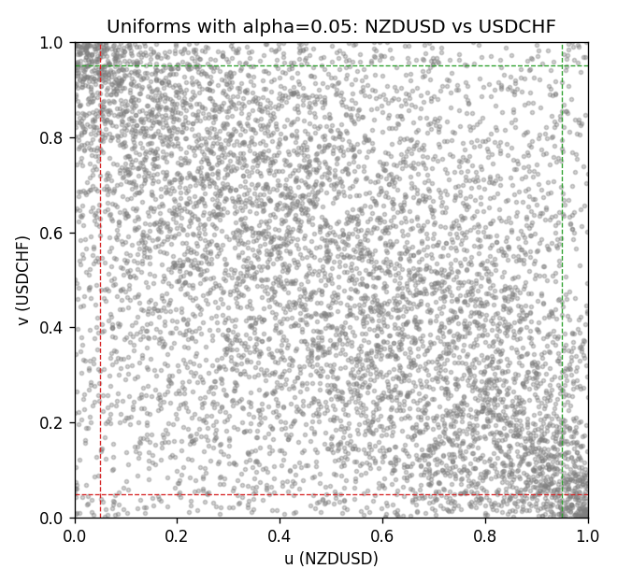

Data report
Every matched row is stored in the sibling Excel workbook named NZDUSD-USDCHF_Tail_D1.xlsx, including u and v. Embedding all rows as a Word table is impractical; this file holds column summaries and the first and last 15 matched rows.
Columns: time, NZDUSD_open, USDCHF_open, NZDUSD_high, USDCHF_high, NZDUSD_low, USDCHF_low, NZDUSD_close, USDCHF_close, NZDUSD_tick_volume, USDCHF_tick_volume, NZDUSD_spread, USDCHF_spread, NZDUSD_real_volume, USDCHF_real_volume, NZDUSD_log_return, USDCHF_log_return, u, v
Column summaries (matched calculation rows)
column | count | mean | std | min | 25% | 50% | 75% | max
NZDUSD_open | 7185 | 0.65641395 | 0.10821881 | 0.3913 | 0.59137 | 0.6684 | 0.72499 | 0.88218
USDCHF_open | 7185 | 1.0976269 | 0.25248305 | 0.72022 | 0.92053 | 0.98988 | 1.2378 | 1.8219
NZDUSD_high | 7185 | 0.66033247 | 0.10871106 | 0.3961 | 0.59478 | 0.672 | 0.72937 | 0.88421
USDCHF_high | 7185 | 1.1029176 | 0.25422469 | 0.73305 | 0.92474 | 0.99353 | 1.2423 | 1.8313
NZDUSD_low | 7185 | 0.65272894 | 0.10781325 | 0.3897 | 0.58811 | 0.66417 | 0.72099 | 0.87988
USDCHF_low | 7185 | 1.0925083 | 0.25089773 | 0.08565 | 0.91719 | 0.98622 | 1.2317 | 1.8121
NZDUSD_close | 7185 | 0.65649284 | 0.10821292 | 0.3907 | 0.59165 | 0.6684 | 0.72502 | 0.8822
USDCHF_close | 7185 | 1.0976163 | 0.25237603 | 0.72025 | 0.92079 | 0.98995 | 1.2379 | 1.8217
NZDUSD_tick_volume | 7185 | 68718.644 | 123140.12 | 16 | 5587 | 33899 | 58511 | 1127682
USDCHF_tick_volume | 7185 | 74335.19 | 113494.16 | 18 | 12810 | 40241 | 70443 | 858589
NZDUSD_spread | 7185 | 30.278775 | 25.647496 | 0 | 9 | 17 | 40 | 80
USDCHF_spread | 7185 | 26.036326 | 24.697816 | 0 | 5 | 16 | 50 | 100
NZDUSD_real_volume | 7185 | 1.6703703e+10 | 8.4983725e+10 | 0 | 0 | 0 | 0 | 2.705649e+12
USDCHF_real_volume | 7185 | 2.3294091e+10 | 8.9133595e+10 | 0 | 0 | 0 | 0 | 1.9331921e+12
NZDUSD_log_return | 7185 | 2.019e-05 | 0.00763908 | -0.07027433 | -0.0042485 | 0.00023717 | 0.00458461 | 0.05966839
USDCHF_log_return | 7185 | -7.205e-05 | 0.00658891 | -0.19545699 | -0.0033516 | 8.095e-05 | 0.00331593 | 0.09051364
u | 7185 | 0.5 | 0.28865504 | 0.00013916 | 0.25006958 | 0.5 | 0.74993042 | 0.99986084
v | 7185 | 0.5 | 0.28865504 | 0.00013916 | 0.25006958 | 0.5 | 0.74993042 | 0.99986084
First 15 matched rows (selected columns)
time | NZDUSD_log_return | USDCHF_log_return | u | v
1999-01-05 | -0.0018597736 | 0.0039424743 | 0.37301698 | 0.78388533
1999-01-06 | 0.0020455609 | 0.013605652 | 0.61424993 | 0.9838575
1999-01-07 | 0.0062963171 | -0.0093883841 | 0.82618981 | 0.058725299
1999-01-08 | -0.00055396548 | 0.011040268 | 0.45129418 | 0.96715836
1999-01-11 | 0.010290425 | 0.0052963193 | 0.93000278 | 0.84539382
1999-01-12 | -0.0053157489 | -0.0098275602 | 0.20539939 | 0.052602282
1999-01-13 | -0.0099742238 | -0.018259701 | 0.079042583 | 0.0057055385
1999-01-14 | -0.00018564931 | -0.0024256692 | 0.47495129 | 0.30475925
1999-01-15 | -0.00074294208 | 0.01794228 | 0.4405789 | 0.9948511
1999-01-18 | -0.0018597736 | -0.0031856384 | 0.37301698 | 0.25911495
1999-01-19 | 0.0018597736 | -7.2518946e-05 | 0.60311717 | 0.48608405
1999-01-20 | 0.0040793678 | 0.0072259871 | 0.72522961 | 0.90801559
1999-01-21 | 0.0040627941 | -0.0038232689 | 0.72404676 | 0.22669079
1999-01-22 | -0.012051689 | -0.0001445609 | 0.052602282 | 0.47968272
1999-01-25 | -0.0035504102 | 0.0024546976 | 0.28611188 | 0.69148344
Last 15 matched rows (selected columns)
time | NZDUSD_log_return | USDCHF_log_return | u | v
2026-10-13 | 0.0047326165 | -0.0024955621 | 0.75758419 | 0.29988867
2026-10-14 | -0.0037306483 | 0.0029388325 | 0.27692736 | 0.72529919
2026-10-15 | 0.0047634855 | -0.0097855323 | 0.75911495 | 0.053576399
2026-10-16 | 0.0057501001 | -0.0036230826 | 0.80517673 | 0.23810186
2026-10-19 | 0.0018917133 | 0.0036351779 | 0.60590036 | 0.76816031
2026-10-20 | 0.0037199341 | -0.0026281224 | 0.70609519 | 0.29181742
2026-10-21 | 0.0030923331 | -0.00040027413 | 0.6747843 | 0.45574729
2026-10-22 | -0.0033035227 | -0.0048036381 | 0.29557473 | 0.18355135
2026-10-23 | 0.0030929853 | 0.005652514 | 0.67492346 | 0.86070136
2026-10-26 | -0.0028993932 | 0.0018407959 | 0.31603117 | 0.64361258
2026-10-27 | -0.00026399852 | 0.0026100526 | 0.4684108 | 0.7012246
2026-10-28 | -0.0097283914 | -0.0010142111 | 0.083913164 | 0.40787643
2026-10-29 | 0.00062190714 | -0.0048680164 | 0.52546618 | 0.18048984
2026-10-30 | 0.00019537668 | 0.00071594559 | 0.49805177 | 0.55385472
2026-11-02 | -0.0025962955 | -0.0071459744 | 0.33133871 | 0.10311717

